Linux day - 1

What is Linux?
Linux is a free and open-source operating system based on the Unix concept. It controls computer hardware and allows users to run programs.
- Developed by Linus Torvalds in 1991.
- Kernel-based system, where Linux Kernel is the core that manages hardware and resources.
- Often used for servers, desktops, embedded systems, cloud, and mobile devices (Android is based on Linux).

Benefits of Using Linux
- Free & Open Source – No license cost, source code available for modification.
- Secure – Fewer viruses and strong permission-based access.
- Stable & Reliable – Rarely crashes; suitable for servers.
- Customizable – You can modify everything from kernel to desktop environment.
- Lightweight – Can run on older hardware.
- High Performance – Efficient use of system resources.
- Multiuser & Multitasking – Multiple users can work without interfering with each other.
- Community Support – Large global community for troubleshooting and learning.

Linux Distributions
Linux has many variants (called distributions or distros) built on the Linux kernel.
Some popular ones are:
- Ubuntu – Beginner-friendly, widely used on desktops and servers.
- Debian – Stable, community-driven distribution.
- Fedora – Cutting-edge features, backed by Red Hat.
- Red Hat Enterprise Linux (RHEL) – Commercial version for enterprises.
- CentOS – Free community version of RHEL (now replaced by CentOS Stream).
- openSUSE – Stable and versatile, good for servers and desktops.
- Kali Linux – Designed for penetration testing and security research.
- Arch Linux – Lightweight, highly customizable for advanced users.

Architecture ofLinux OS
The Linux operating system's architecture mainly contains some of the components: Hardware Layer, Kernel, System Library, System, and Shell utility.

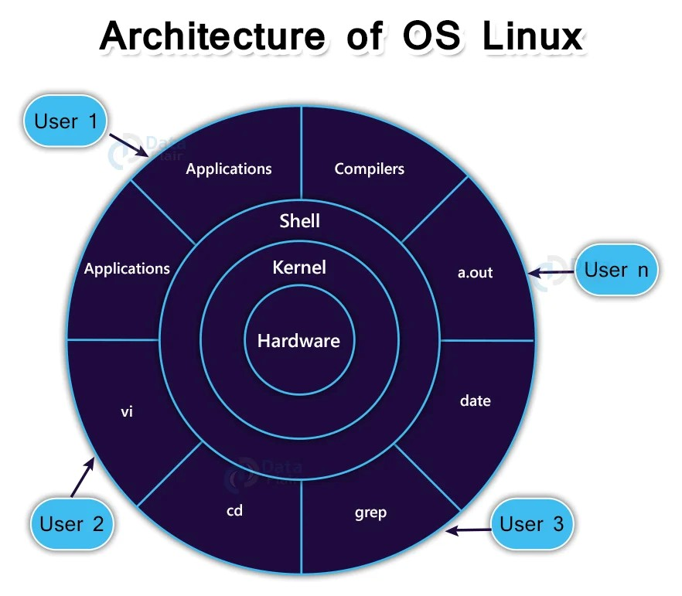

Hardware Layer: The Linux operating system contains a hardware layer that consists of several peripheral devices like CPU,HDD, and RAM
Kernel: The kernel is one of the core sections of an operating system. It directly interacts with system hardware and manages resources. It is responsible for each of the major actions of the Linux OS.
Shell: It is an interface between the kernel and the user. It can afford the services of kernel. It can take commands through the user and run the functions of the kernel

Commands:
- ls – List Directory Contents
Use: Lists files and folders in the current directory.
Syntax: ls

- whoami – Display Current User
Use: Shows the username of the currently logged-in user.
Syntax: whoami

- pwd – Print Working Directory
Use: Displays the full path of the current directory. (absolute path)
Syntax: pwd

- clear – Clear Terminal Screen
Use: Clears the terminal screen for better visibility.
Syntax: clear
Shortcut key: ctrl+l

- history – Show Command History
Use: Displays previously executed commands.
Syntax: history
You can re-run a command using:
!<history_number>

- mkdir – Create a Directory
Use: Creates a new directory as named in the current location.
Syntax: mkdir dir_name
Example: mkdir mydir

Creates a new directory named mydir in the current location.
After mkdir, use ls to check if mydir was created.

To Create Multiple Directories

mkdir dir1 dir2 dir3 swati

Creates 4 directories at once.

7.man ls – Manual for ls Command
Use: Opens the manual (help) for the ls command.
Use q to exit the manual.
- man mkdir – Manual for mkdir Command
Use: Displays detailed usage and options for mkdir.

- cd – Change Directory
Use: Navigate to directories.
Syntax: cd dir_name
Example: cd mydir

Tips for Day 1:
  - Always use pwd to check where you are before creating or moving into directories.
  - man <command> is your best friend for learning more about any Linux command.
  - Use Tab key for auto-completion to save time.
Use up and down ar

